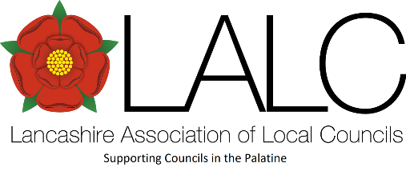
April 2026

Local Council: Billinge Chapel End

Electorate: 4763 Invoice No: 67145

MEMBERSHIP INVOICE 1 April 2026 ~ 31 March 2027

Description | Amount
Subscription: NALC*  Subscription: LALC  Contribution to Area Secretary (if applicable)  Notes  Payment terms: Due by the end of May 2026 | £409.62  £376.79  £10.00
The preferred method of payment is by BACs or electronic banking to NatWest:  Sort: 01-00-53 Account: 12756288 | £796.41

Notes:
* NALC fee is a fixed rate fee 0.0860 per elector for 2026/27
See service updates below (page 2)

Please make cheques payable to LALC to the address above and forwarded with the information below.
------------------------------------------------------------------------------------------------------
To: Billinge Chapel End Invoice No: 67145

District: St. Helens Total: £796.41

IMPORTANT SERVICE UPDATES:

LALC membership benefits
– making the most of your membership

Do you think you are aware of all the membership benefits you have access to with your membership?

RESOURCES
Have you created an account on both LALC & NALCs websites? LALC has developed a ‘Members Area’ area on its website, like NALCs ‘My Account’ area.
Both these areas require you to register, creating your own account which you can then log into and research information, news, documents and updates. This is inclusive of both Council employees and Councillors.
Within the ‘Members Area’ & ‘My Account’ your subscription allows access:
- NALCs ‘My Account’ services which include its national campaigning on behalf of our sector, specialist template documents such as vital document eg. Standing Orders, Financial Regulations, publications, sector news and more.
- LALCs ‘Members Area’ area contains a library of documents, templates, updates, bulletins, guides and procedures documents.
ADVICE
Available directly from LALC, call or email advice@lalc.org.uk to receive:
- Advice for councils - guidance and advice on all aspects of Parish & Town Council workings, identifying essential local government legislation, policy and best practice materials.
- Specialist advice from LALC & NALC - can be accessed through LALC, such as Finance & VAT, Health & Safety, Employment Law, Human Resources, Data Protection, FOIs, SARs and more. This is referred to specialist retained advisors.
NETWORKING
Area Committees operate to bring together councils from the same area to meet, discuss projects, network, pass on recommendations or contacts. They are held in the locality and may have speakers or training elements to the events.
Make the most of this forum and nominate Councillor representatives to attend the meeting and report back to full council.

